|  |
| --- |
| Accident Analysis Software Executive Summary |
| Nicolas Donaldson, Toshimitsu Ota, Juniper Lethbridge  2810ICT Software Technologies  October 4, 2022 |

Table of Contents

Abstract 2

Introduction 3

Analysis 1: All Accident Information 4

Analysis 2: Accident Hourly Average 5

Analysis 3: Accidents Containing User Entered Accident Type 6

Analysis 4: Impact of Alcohol Within Accidents 7

Hourly Average Involving Alcohol Related Incidents Chart 7

Accident Type Chart Involving Alcohol Related Incidents 8

By Month Chart Involving Alcohol Related Incidents 9

By Day Chart Involving Alcohol Related Incidents 10

Analysis 5: Geographical Analysis of Accident Data 11

Top 10 LGA Chart 11

Region Chart 12

Map Chart 13

# Abstract

The analysis of road accidents within the state of Victoria, from 2015-2016 has illustrated a few key findings. Firstly, alcohol related incidents occur more frequently between Friday and Sunday, within the heart of Melbourne city, and especially within the month of December. Accidents involving alcohol are typically a collision with another vehicle, or a collision with a fixed object. Using all the information stated, an ad campaign can be targeted at the right place, at the right time. For reducing non-alcohol related road incidents, understanding additional findings is also important. Most accidents occur between 8am-10am, and 3pm-6pm. This suggests the school/work rush impacts the likelihood of road accidents. It is recommended for future research that the department of transport for Victoria investigates the infrastructure of the city of Melbourne and surrounding roads, to find correlations between the data produced by this software, and the quality of roads accessible to domestic transport.

# Introduction

The purpose of this report is to demonstrate the features of the Accident Analysis Software. To do this, a systematic approach will be taken, where each feature will be demonstrated individually to analyze data from within a 12-month period. This period will be from 01/01/2015 – 01/01/2016. Each demonstration will include the results, additional comments, images, and further analysis. Within this 12-month period, the following functions will be used to demonstrate the requirements of the software, and the benefits it may bring to potential users:

* For a user-selected period, display the information of all accidents that happened in the period.
* For a user-selected period, produce a chart to show the number of accidents in each hour of the day (on average).
* For a user-selected period, retrieve all accidents caused by an accident type that contains a keyword (user entered), e.g., collision, pedestrian.
* Allow the user to analyse the impact of alcohol in accidents – ie: trends over time, accident types involving alcohol, etc.
* Produce a Visualisation view for the user to understand accident data relating to geographical location information. This will be categorised into Local Government Areas.

# **Analysis 1: All Accident Information**

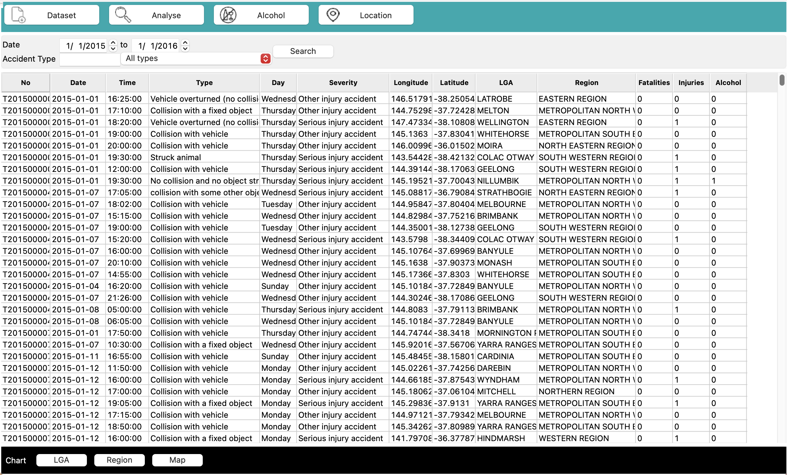

Analysis:

All accident information can be seen for the selected period. All data for the accidents are visible, including Date, Time, Type, Region, Severity, LGA, Fatalities, and Alcohol.

# **Analysis 2: Accident Hourly Average**

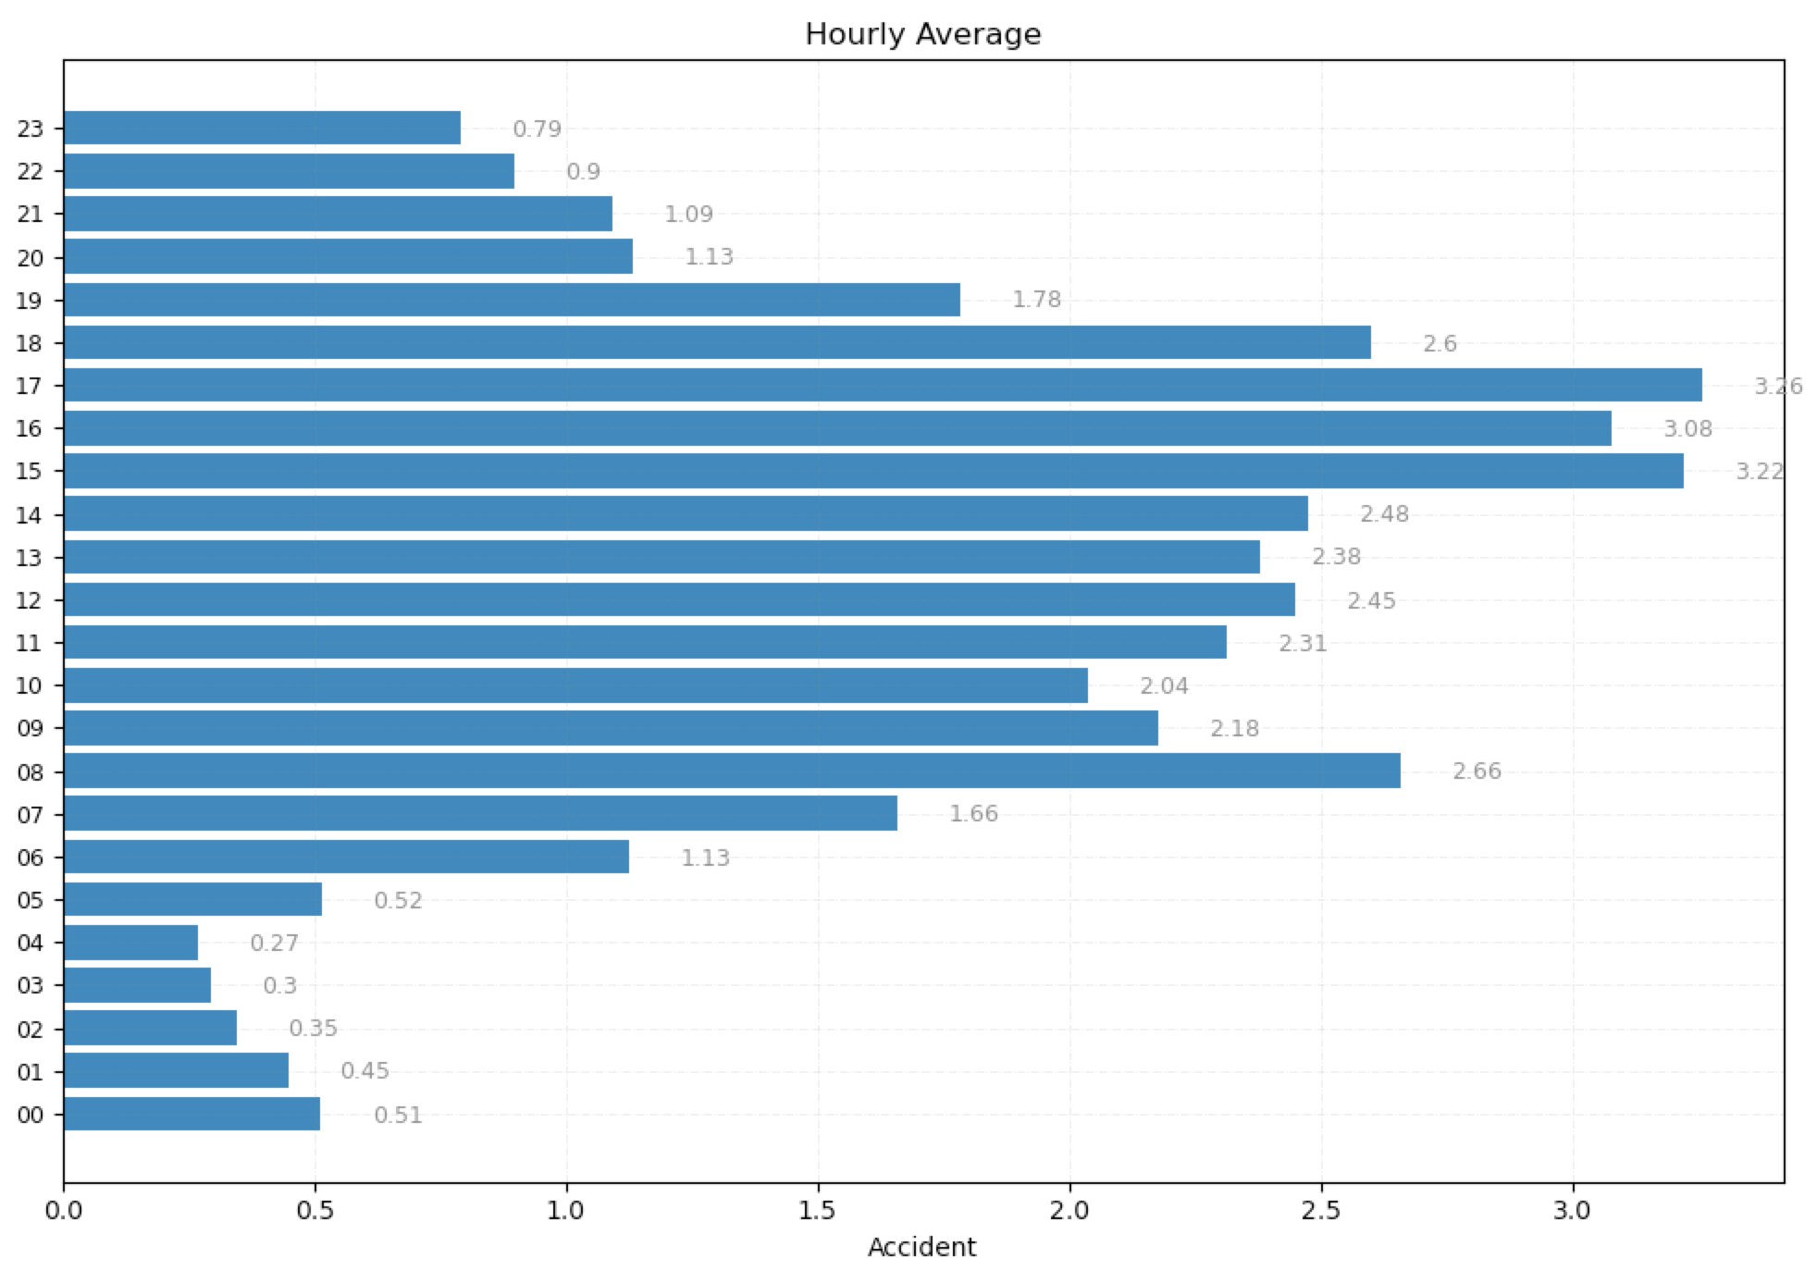

Analysis:

Within the selected period, accidents are more likely to occur between 3pm-6pm. It can be argued that this is due to peak hour traffic, caused by school and work finishing. Furthermore, accidents have a high average between 8am-10am. This may justify the previous statement, as peak traffic occurs in this time also, due to work and school commencing. It is between 2am-4am that the least number of accidents generally occur.

# **Analysis 3: Accidents Containing User Entered Accident Type**

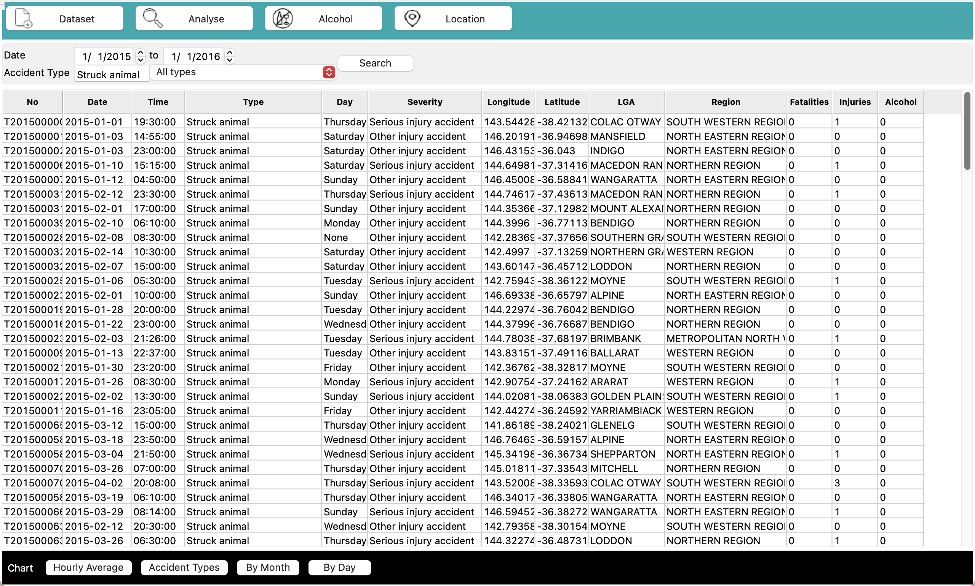

Analysis:

‘Struck animal’ was entered in the search bar, and all results with accident type ‘Struck animal’ have been returned.

Analysis 4: Impact of Alcohol Within Accidents

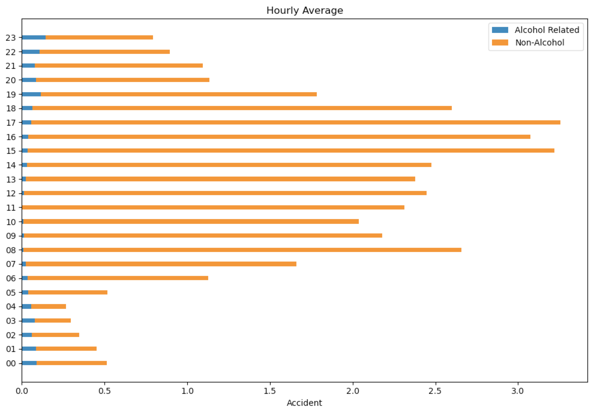

## Hourly Average Involving Alcohol Related Incidents Chart

Analysis:

Within the selected period, alcohol related accidents occur more frequently during the night. All hours of the night have a significant portion of accidents containing alcohol related incidents. It is also important to note that almost no alcohol related incidents tend to occur from 8am-12pm.

## Accident Type Chart Involving Alcohol Related Incidents

Analysis:

Within the selected period, alcohol related incidents typically occur with a collision with a vehicle, or a collision with a fixed object. As no alcohol related incidents occur for some accident types, this analysis justifies that an ad campaign for drunk drivers should focus on the collision with objects or vehicles, and not something like a pedestrian being struck.

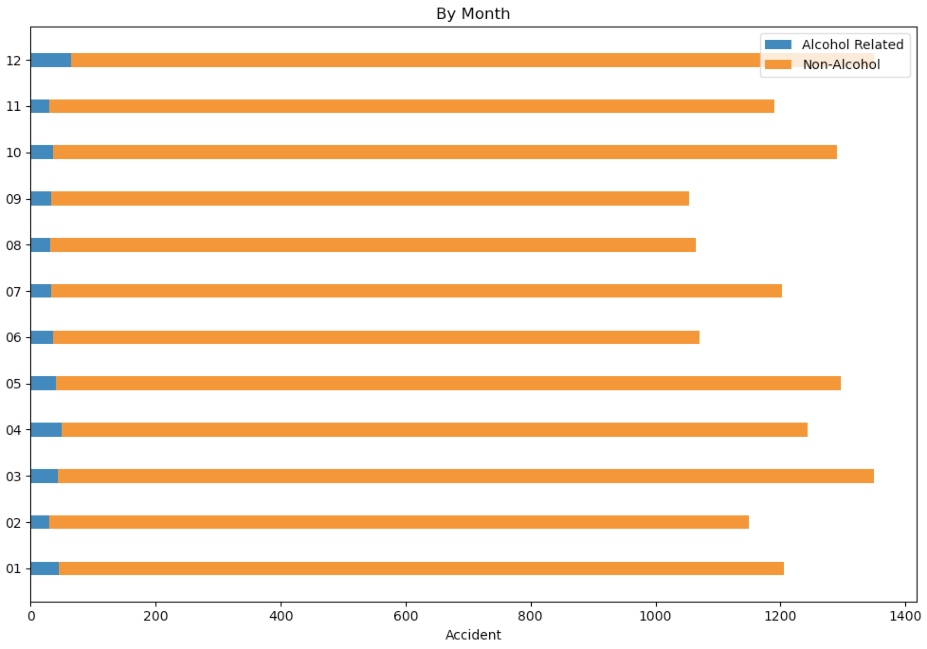

## By Month Chart Involving Alcohol Related Incidents

Within the selected period, alcohol related incidents across the year are relatively even. It is the month of December however that has an increase in alcohol related incidents. One may argue that this is because of Christmas, Boxing Day, or New Year’s Eve where an increase in alcohol consumption occurs.

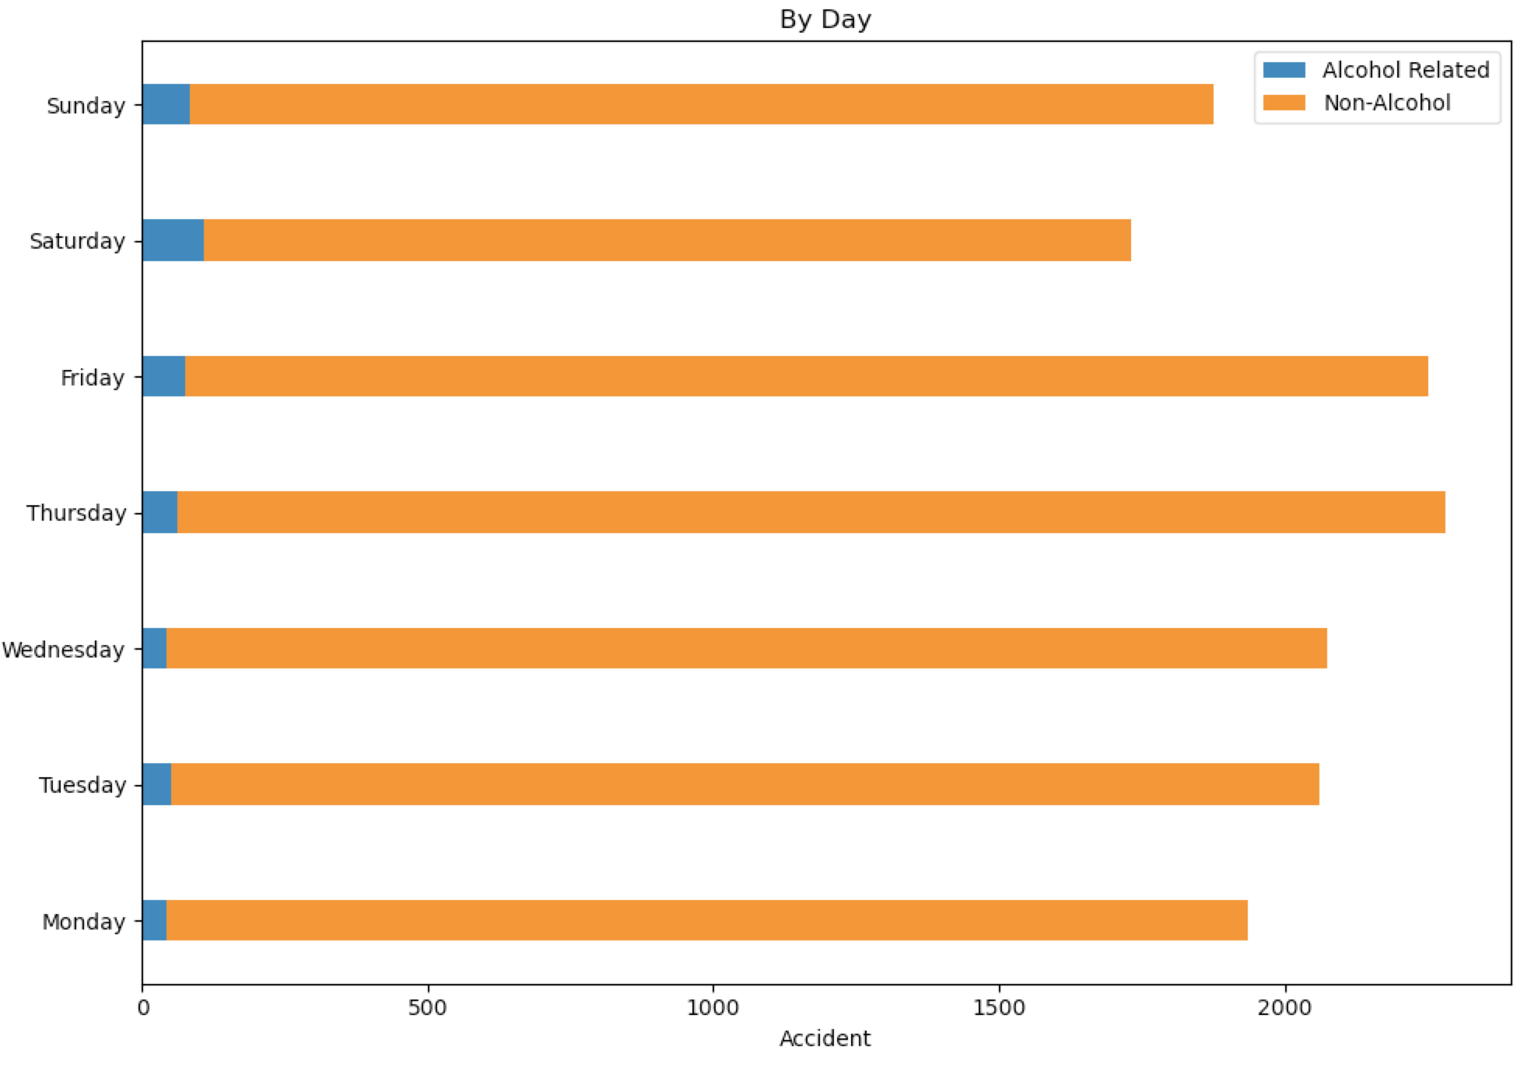

## By Day Chart Involving Alcohol Related Incidents

Analysis:

Within the selected period, Alcohol related incidents occur more frequently from Friday-Sunday. This is due to the working week finishing and an increase in people consuming alcohol due zero work commitments on the weekend.

# **Analysis 5: Geographical Analysis of Accident Data**

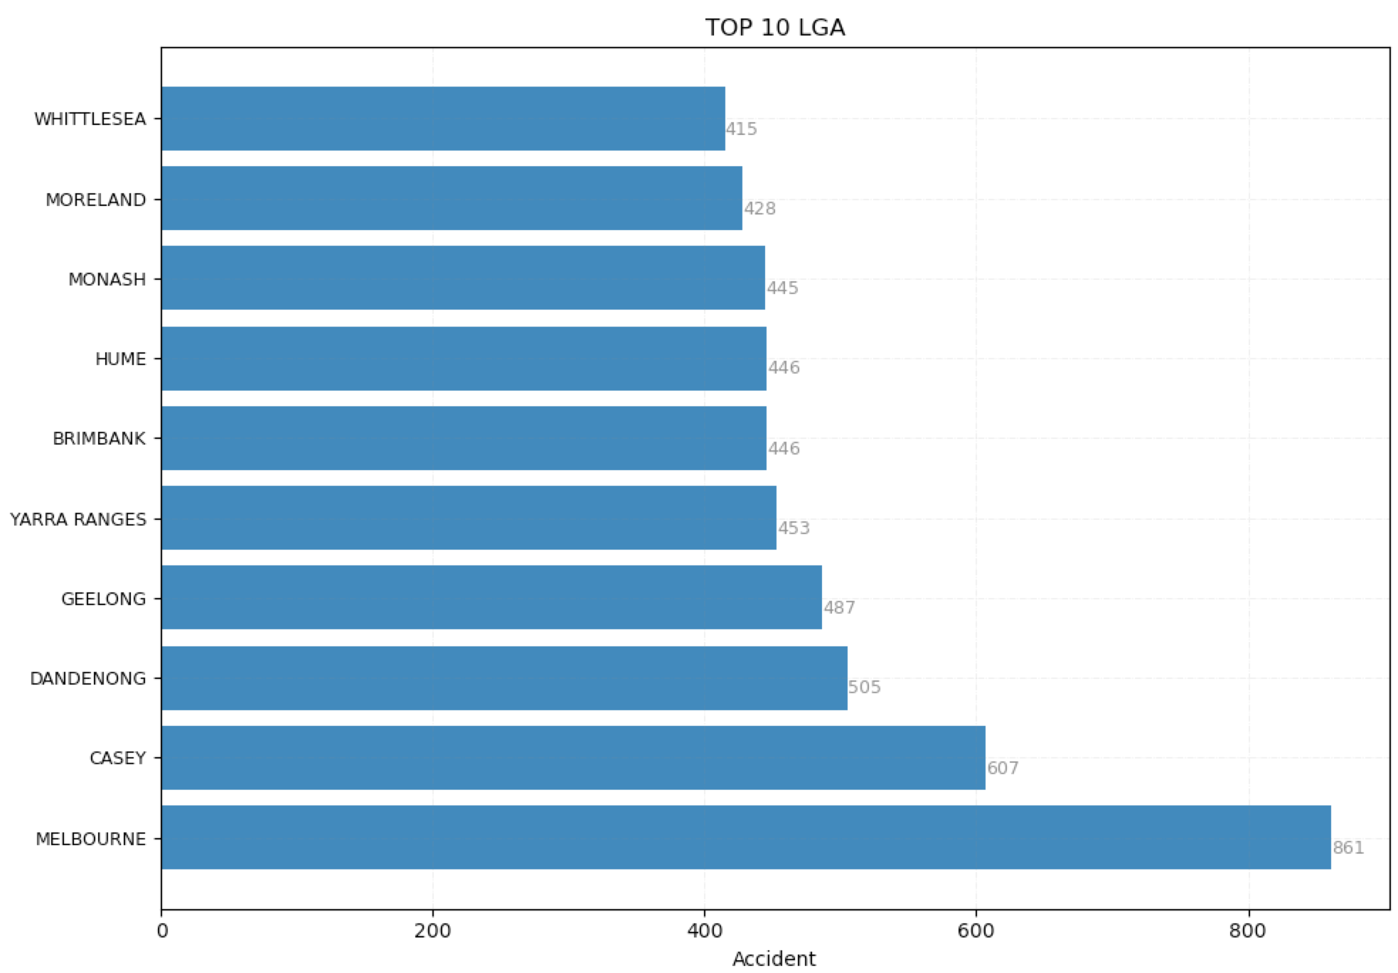

## Top 10 LGA Chart

Analysis:

Within the selected period, Melbourne is the local government area with the most road accidents. Due to the large number of accidents that Melbourne leads by, it can be argued that targeted ads or further investigation could be specifically applied solely to Melbourne, in an effort to reduce road accidents.

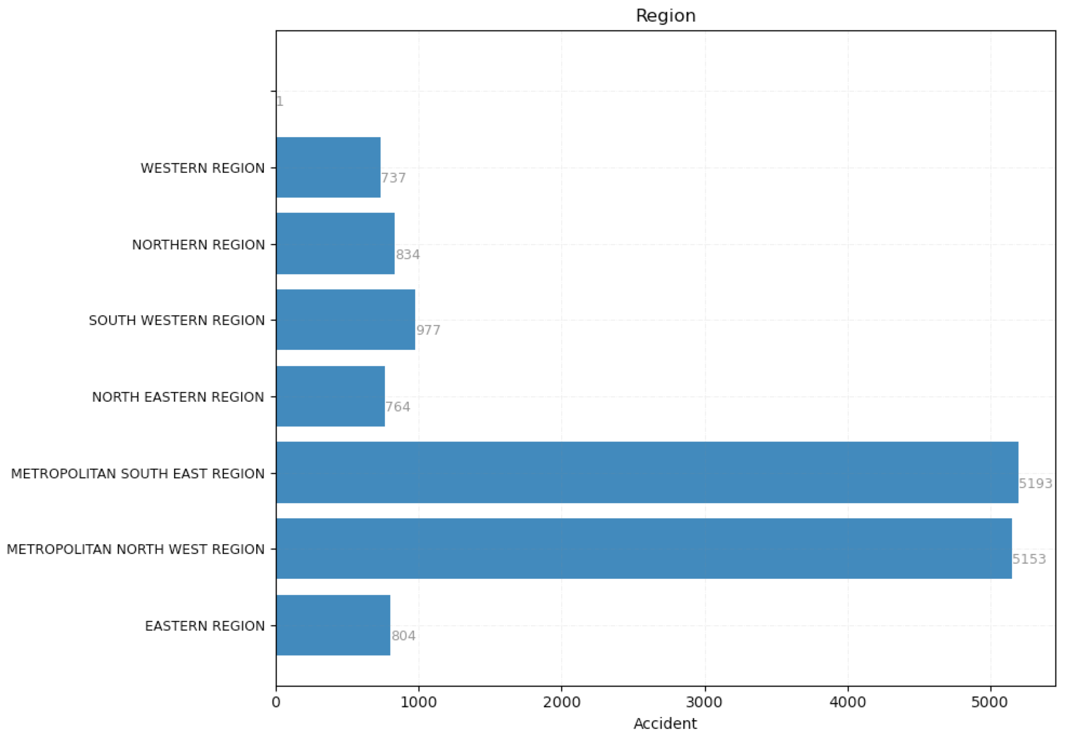

## Region Chart

Analysis:

Within the selected period, a significant number of accidents is shared between Metropolitan Southeast Region, and Metropolitan North West Region. This indicates that efforts to investigate methods into reducing road accidents should be targeted towards these two regions.

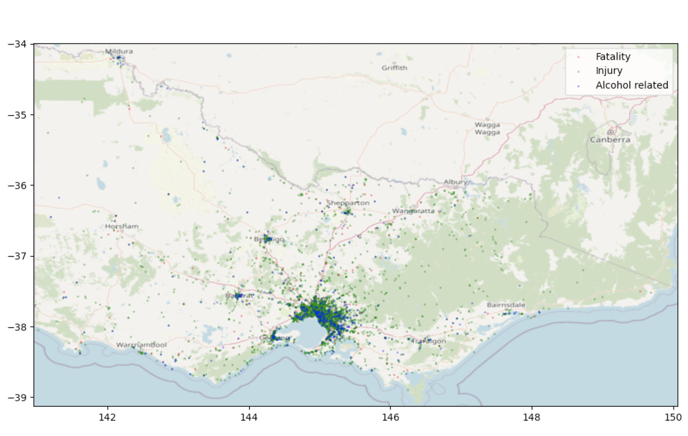

## Map Chart

Analysis:

Most accidents have occurred within or around the city of Melbourne. This makes reasonable sense, as most of the Victorian population resides within Melbourne. Another important discovery is that alcohol related incidents appear more frequently within the heart of the city. One possible explanation may be the large presence of bars, nightclubs, and restaurants that appear in the heart of Melbourne.